Question 1:

[org 0x0100]

mov ax,6
mov bx,5

cmp ax,bx
jg increment
jng decrement
jmp exit

increment: inc ax
mov [num1],ax
jmp exit

decrement: dec ax
mov [num1],ax

exit: mov ax, 0x4c00
int 21h

num1: dw 0
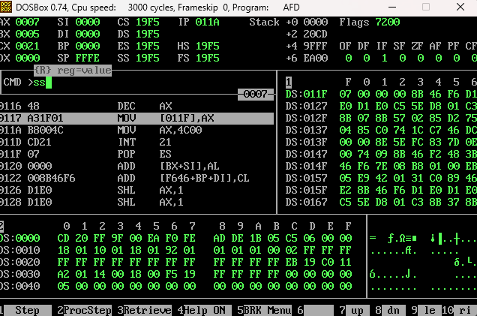

Question 2 :
[org 0x0100]

mov cx,0
mov dx,5

l1: mov ax,[num1]
mov bx,6
add ax,bx
mov [num1],ax
inc cx
cmp cx,dx
jne l1
jmp exit

exit: mov ax, 0x4c00
int 21h

num1: dw 0

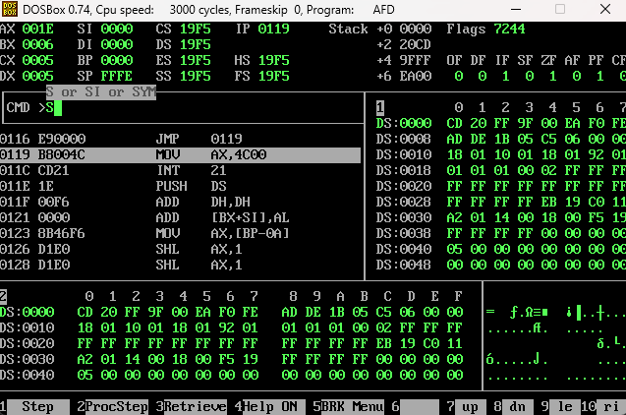

Question 3:
[org 0x0100]

arr: dw 5,3,8,4,1
swap: db 0

start: mov bx,0
mov byte [swap],0

l1: mov ax,[arr+bx]
cmp ax,[arr+bx+2]
jbe ns

mov dx,[arr+bx+2]
mov [arr+bx+2],ax

mov [arr+bx],dx
mov byte [swap],1

ns: add bx,2
cmp bx,8
jne l1

cmp byte[swap],1
je start

mov ax,0x4c00
int 21h

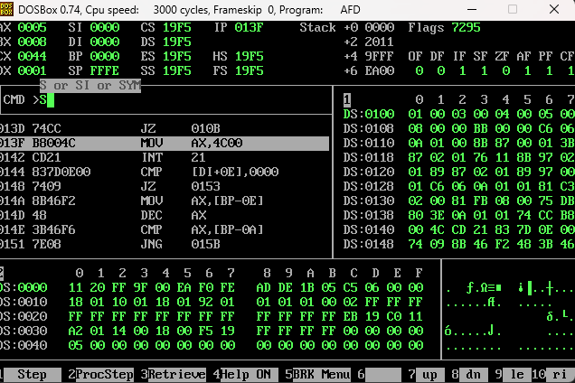
Question 4:
[org 0x0100]

jmp start
num1: dw 1,2,6,4,5,3

start:

mov bx,0
mov si,0
jmp l2

l1:
mov si,bx

l2:
mov ax,[num1+bx]
add si,2
mov dx,[num1+si]
cmp ax,dx
jge ns

mov [num1+bx],dx
mov [num1+si],ax

ns:
cmp si,10
jne l2
add bx,2
cmp bx,10
jne l1

mov ax,0x4c00
int 21h

